Schools bulletin – For all schools with pupils in Year 3+
Title: - Free School Meals system update:
Message:
As advised on the 17^{th of} November, following the successful data migration and schools sign up of the Free School Meals (FSM) system, we want to share some important information about schools’ responsibility for processing “pending applications”
What is a pending application?
A pending application is an application which the FSM system was unable to confirm the applicant being eligible for the child to receive the FSM.
The system will carry out a check of entitlement without needing proof of benefit. However, on occasion, the system can’t always determine eligibility. In these instances, the applicant is asked to upload proof to the system for the school to review and approve/refuse.
How will schools process applications?
To the most part schools won’t need to process applications.
The DfE have produced some slides (attached) for all schools to review and follow. These slides cover all aspects of the system including “how to process appeals” found in section 7 (page 41-45). This section provides specific details explaining how to access a “pending application” and how to review supporting evidence to approve or decline. Additional guidance can also be found on the DfE system (Highlighted in yellow in below screenshot).

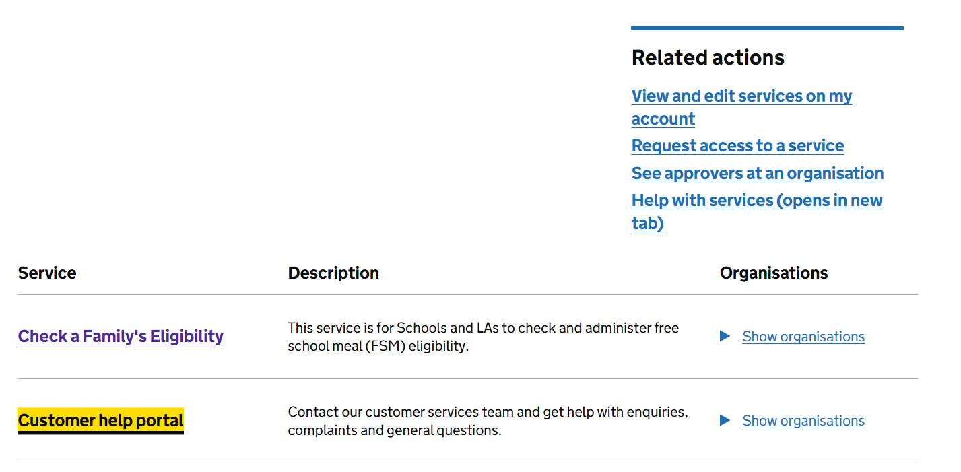
How many applications will a school need to manually review/process?
93% of all FSM applications will be processed through the system without schools needing to do anything. 7% of applications may need the school to review documents and process.
When are the drop-in sessions happening?
An initial session to walk through the system will be held on the 11^{th of} December 14:00 – 15:30. Invites will be sent to all schools who have signed up.
A subsequent session will be held on the 16^{th of} December.

