RE@Herts

Newsletter April 2026

Welcome from the RE Adviser, Shammi Rahman



Welcome and I hope everyone had a wonderful Eid, Easter, Passover and Vaisakhi.

This year, I had the privilege of spending Passover with close friends, and it was a powerful reminder of why it is so important both as professionals and as RE teachers to continue building relationships and learning from one another.

Although I have spent many years teaching about the Seder meal, experiencing it first-hand was something entirely different. It brought the story, the symbolism and the sense of community to life in a way that no textbook can fully capture.

Coming together outside of the classroom, sharing in one another’s sacred stories and traditions, reminds us that the power of unity is not just something we teach, it is something we experience. These lived experiences shape how we teach and how we support pupils to engage with religion and belief in meaningful and respectful ways.

Shammi Rahman
RE Adviser, Hertfordshire Shammi.Rahman@hfleducation.org

Religion and worldviews: learning beyond simplification

Recently, I listened to Peter Sanders speak about his journeys among Muslim communities in China. His reflections offered a timely challenge to how Islam is often represented in education.

Too often, Islam is presented in singular, simplified terms. Yet the lived reality is far more complex. Communities such as the Hui and Uyghur peoples demonstrate how Islamic belief and practice are shaped through deep engagement with cultural and philosophical traditions, including Confucianism, Taoism and Buddhism.

This is why a worldviews approach is so important in RE. Rather than presenting religions as fixed systems, we need to help pupils understand how beliefs are interpreted, adapted and lived across different contexts. If we want pupils to truly understand religion in the modern world, we must move beyond simplification and begin with lived reality.


Peter Sanders - Peter Sanders
National events
Marking important events - Yom HaShoah (Holocaust Remembrance Day)
Yom HaShoah was marked earlier this week. This remains an important opportunity for schools to continue educating about the Holocaust and reflecting on its ongoing relevance.
Organisations such as Voices of the Holocaust provide powerful survivor testimony and educational support. Schools are encouraged to engage with these resources where possible.
Online Q&A session with Anna Silver – 21 April
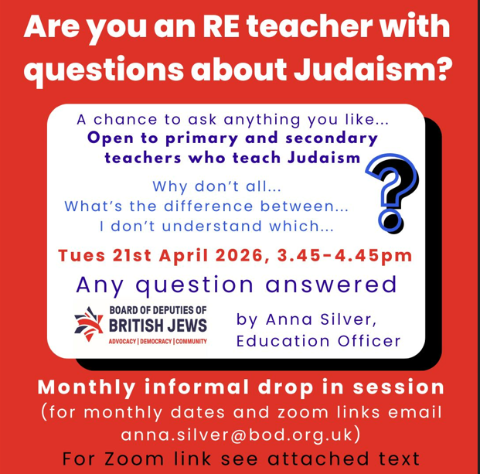
Jewish Culture Month: 16 May – 14 June
Email anna.silver@bod.org.uk for further details.

Developing coverage of Dharmic traditions
As we reflect on recent celebrations, it is also important to ensure that Dharmic traditions are given strong representation within our curriculum.

Vaisakhi
Vaisakhi is one of the most important festivals in Sikhism, marking the founding of the Khalsa in 1699 by Guru Gobind Singh.
It is a powerful opportunity for pupils to explore:
- identity and belonging
- commitment and equality
- courage and standing up for what is right
The themes of Vaisakhi resonate strongly with wider school values and provide meaningful opportunities for reflection and discussion.
Looking ahead
Schools may also wish to plan for upcoming festivals such as:
- Ram Navami (Hinduism)
- Hanuman Jayanti (Hinduism)
- Vesak / Buddha Day (Buddhism, May)
These provide rich opportunities to explore diversity, lived practice and shared human values.
Local focus
St Alban Day (22 June) free assembly resource

St Alban Day is an important opportunity for Hertfordshire schools to explore local history and religious heritage.
St Alban, Britain’s first Christian martyr, is remembered for his courage, compassion and willingness to stand up for his beliefs. His story provides valuable opportunities for pupils to reflect on:
- moral courage
- respect for others’ beliefs
- standing up for what is right
These themes link strongly to RE, SMSC and British Values. SACRE has worked with St Albans Education Centre to produce St Alban slides and accompanying notes for assembly use.

St Alban is celebrated on 20th June 2026 with the Alban Pilgrimage Procession with 12-foot puppets. A dramatic, visual retelling of Alban’s story, starting at 11 am at St Peter’s Church and ending at the Cathedral.

Save the date: RE Day Conference - 21 October 2026
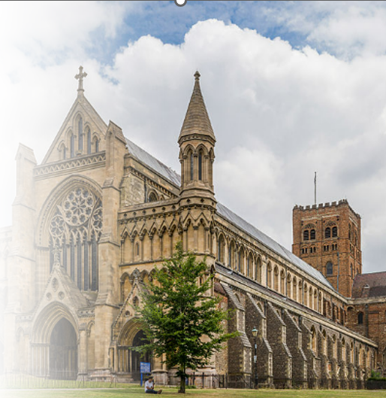
We are excited to be planning a county-wide RE conference for KS4 and KS5 students, focused on community cohesion and religion and worldviews and to be held at St Albans Cathedral.
The day will include:
- student workshops
- keynote speakers
- a multi-faith panel discussion
- opportunities to engage with a range of religious and non-religious perspectives
The Jewish Living Exhibition will also be available for schools to visit throughout the day.
Please hold the date but for early booking enquires contact Steve Clarke, Education Officer via email Steve.Clarke@stalbanscathedral.org

Continuing Professional Development Opportunities

Hertfordshire SACRE RE Network Meeting
We were delighted welcome Katie Gooch, Lead for East Anglia, RE Hub to our March RE Online Network meeting. Katie gave a useful presentation on the RE Hub and the support that it provides to RE Leads. The RE Hub enables teachers to teach with greater confidence through direct access to the support, knowledge, training and resources available in their region.

Shammi Rahman gave an update on national developments including Ofsted and the Curriculum and Assessment Review.

Please click here to access the slides and useful links from the Network meeting: RE and SACRE: newsletters and networking - Hertfordshire Grid for Learning

The next date for the RE Network will be on the 19th May between 4-4:45pm and the focus will be on Assessment for Primary and Secondary, general discussion and Q&A.

Please email juliet.whitehead@hertfordshire.gov.uk
to book a place. There is no cost.

The 2024-25 Hertfordshire Sacre Annual Report

Every SACRE must publish an Annual Report which outlines the statutory work undertaken to support Religious Education (RE) and Collective Worship in Hertfordshire schools during the last academic year. This report is sent to the DfE (see link above).

Resources Spotlight

Jewish Living Online(JLO) is a new, free, digital resource for teaching about Jews, Judaism, and antisemitism, created by The Board of Deputies of British Jews in partnership with ADL.

JLO is a comprehensive, authentic and engaging resource for pupils from KS3 and above. It contains information via multimedia content (including real British Jewish voices), discussion, and critical thinking questions and assessment tools.
For more information, visit jlo.org.uk or email jlo@bod.org.uk

New publication for RE teachers

We are pleased to share a new publication: The Ultimate Guide to Teaching Secondary RE
By Andy Lewis and contributors (including Adam Smith, Shammi Rahman, Rachael Jackson, Nikki McGee and Matthew Pitcher)
This practical and accessible guide:
- supports curriculum and lesson planning
- offers research-informed approaches
- provides guidance on teaching sensitive topics
It is a valuable resource for both new and experienced teachers that takes a no-nonsense approach to delivering the very best possible RE.
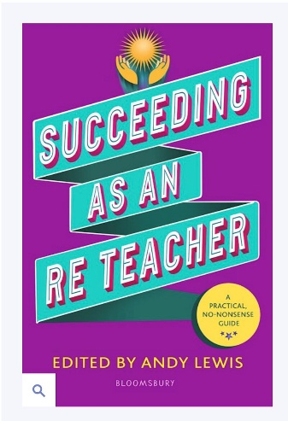

Policy guidance: religious jewellery

Recent guidance highlights the importance of clear policies regarding jewellery in schools, particularly in PE.

Key points:
- Schools have a duty to ensure safety
- Jewellery (including religious items) should be removed or made safe
- Health and safety considerations may take precedence
- Open dialogue with parents and faith communities is strongly recommended

Where removal is not possible, schools should consider adapted participation rather than exclusion.

Here to Help:

Whether it’s meeting statutory requirements, boosting engagement, or finding creative solutions to staffing challenges, we are here to support Hertfordshire schools with tailored advice, resources, and networks. Please contact Shammi Rahman Shammi.Rahman@hfleducation.org or Juliet Whitehead regarding SACRE specific questions juliet.whitehead@hertfordshire.gov.uk

