RE@Herts

Newsletter – Autumn Term 2026
Welcome from the RE Adviser, Shammi Rahman


Welcome back to a new academic year. I hope that you have all managed to find some time over the summer to rest and recharge before what I know will be another busy year.
As we begin the new term, there is much to be positive about in Religious Education. Nationally, RE is receiving renewed attention through discussions about the future National Curriculum, and locally we have an exciting programme ahead, including our RE Conference at St Albans Cathedral in October, our teacher networks and the continuing work of Hertfordshire SACRE.
At the same time, I think it is important that we acknowledge the reality facing many of our schools. Through conversations with RE teachers and leaders, both locally and nationally, I continue to hear about the pressures created by budgets, recruitment and retention, SEND provision, staffing shortages and increasing demands on teachers' time. In some schools, specialist RE provision is particularly stretched, with colleagues working incredibly hard to protect the quality and status of the subject.
This also gives us important context when we think about engagement with SACRE, professional networks and CPD. Lower attendance does not necessarily mean that teachers are less committed to RE, sometimes it reflects just how difficult it can be for colleagues to step away from school when staffing and resources are under pressure.
That makes our professional community even more important. SACRE's role is not simply to monitor RE, but to listen to schools, understand the challenges they are facing and consider how we can provide useful and realistic support. Our networks are also an opportunity to share expertise and remind ourselves that, even when someone may be the only RE specialist in their school, they are part of a much wider community of teachers and colleagues committed to the subject.
There are undoubtedly challenges ahead, but there are also reasons for optimism. The growing national conversation about RE provides an important opportunity to strengthen the subject and to ensure that every young person has access to high-quality education about religious and non-religious worldviews.
As always, please do get in touch if there is anything that SACRE or I can do to support you. I am really looking forward to working with you over the coming year and especially to meeting many of our GCSE and A Level students and their teachers at St Albans Cathedral in October.
Wishing you and your school community a positive start to the new academic year.
Shammi Rahman
RE Adviser, Hertfordshire Shammi.Rahman@hfleducation.org

SACRE Member Spotlight: Nish Sabur
We are delighted to spotlight the work of Nish Sabur, one of our Hertfordshire SACRE members, who has recently written for RE about Religious Education in Alternative Provision.
In Inspiration and Evolution: RE in Alternative Provision, Nish reflects on the development of RE within his setting and the opportunities and challenges involved in creating meaningful Religious Education for pupils in Alternative Provision.
It is a valuable reminder that high-quality RE needs to respond to the pupils and contexts we serve, while still providing opportunities for young people to encounter challenging questions about religion, belief, identity and the world around them.
We are very fortunate to have Nish's experience and expertise represented on Hertfordshire SACRE, and I would really encourage colleagues, whether working in mainstream or Alternative Provision to take a few minutes to read his reflections.
Read Nish's blog on RE:ONLINE: https://www.reonline.org.uk/blog/inspiration-and-evolution-re-in-alternative-provision/

National events
National RE Update: an important moment for RE
There are significant developments nationally in Religious Education. Following the Curriculum and Assessment Review, the Government has announced that Religious Education will be included in the September 2026 consultation on the future content of the National Curriculum.
A specialist RE Task and Finish Group has developed proposed Programmes of Study and national standards for RE. The proposals are intended to provide a nationally consistent benchmark for breadth, depth and ambition, built around substantive, disciplinary and personal knowledge, while recognising the different legal arrangements that apply to different categories of school.
This is an important moment for the subject. Hertfordshire SACRE will continue to follow developments closely and keep schools updated as the consultation and subsequent national work progress.

Ofsted: keeping curriculum depth in view
Ofsted’s subject report Deep and meaningful? remains a useful reference point for RE leaders. It highlighted the importance of curriculum depth, carefully selected content and ensuring that pupils build and retain increasingly complex knowledge rather than encountering a curriculum that is broad but superficial.

NATRE: the national picture for secondary RE
NATRE’s Secondary Survey 2025 provides a useful snapshot of provision across England. It is worth revisiting as national discussions about the future of RE develop, particularly when considering curriculum time, staffing and access to high-quality provision.
NATRE: RE and the September national curriculum consultation
Ofsted: Deep and meaningful? The religious education subject report
NATRE Secondary Survey 2025

Inter Faith Week 2026
8-15 November www.interfaithweek.org
The 2026 theme, “Lighting the Way for a Shared Future,” invites schools and communities to celebrate hope, understanding and belonging. Inspired by the symbolism of light in many faiths and beliefs, including Diwali, the theme highlights how coming together can build trust, friendship and mutual respect.
At a time when division and prejudice can create barriers between people, interfaith activities help young people explore shared values, celebrate diversity and develop understanding of different backgrounds. Schools have a vital role to play in fostering these attitudes and helping pupils build inclusive, respectful communities.
Hertfordshire SACRE is creating Secondary and Primary documents with suggested activities for Inter Faith Week 2026. We will publish shortly via the schools bulletin.
www.interfaithweek.org has a link for resources:
Resources | Inter Faith Week 4 Schools

The National Conversation: Next Generation
The National Conversation asks children and young people aged 16 and under the same questions: what brings people together, what divides us, and where they feel they belong.
They are supporting RE teachers across the country to hold a conversation in a lesson, and feedback what you hear. Your students will explore community, belonging, connection, while articulating their thinking and listening to different perspectives. Their ideas will contribute to the Independent Commission on Community and Cohesion. Here’s how you can get involved:
Download the free resources: Young people - The National Conversation for the following:
- A lesson plan for Religion and Worldviews
- Toolkits for teachers and student conversation leaders
- Conversation capture resources

Jewish Living Online (JLO)
JLO is a free digital resource for teaching about Jewish life, Judaism, and antisemitism, created by the Board of Deputies of British Jews in partnership with ADL.
Designed for KS3+, it features engaging multimedia content, British Jewish voices, and tools to support discussion and critical thinking.
Find out more, visit jlo.org.uk or email jlo@bod.org.uk

Online Q&A session with Anna Silver
Are you an RE teacher with questions about Judaism? The British Board of Deputies runs monthly informal Q&A zoom meetings (3.45 to 4.45 pm) open to primary and secondary teachers.
Email anna.silver@bod.org.uk for further details.

Looking ahead to Festivals
Schools may also wish to plan for upcoming festivals such as:
Navaratri: 11–19 October 2026
Dussehra (Vijayadashami): 20 October 2026
Diwali/Deepavali: 8 November 2026
Guru Nanak Gurpurab: 24 November 2026
Hanukkah: 4–12 December 2026
Bodhi Day: 8 December 2026
Christmas: 25 December 2026
These occasions provide rich opportunities to explore lived religion, diversity within traditions and the different ways in which festivals are understood and practised. Dates and observance can vary between communities, so schools are encouraged to use community and denominational sources where appropriate.

Local focus
RE Day Conference - 21 October 2026
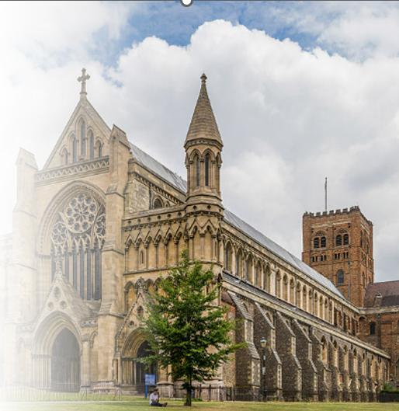
I am really looking forward to welcoming GCSE and A Level Religious Studies students and their teachers to our county-wide RE Conference at St Albans Cathedral on Wednesday 21 October 2026. The day focuses on community cohesion, religion and worldviews, and offers students the opportunity to deepen their subject knowledge, encounter a range of perspectives and engage with some of the big questions at the heart of GCSE and A Level study.
The GCSE morning session has proved extremely popular and is now at full capacity. There are still a limited number of places available for the A Level/KS5 afternoon session. If your school is interested in attending, please contact Steve Clarke at St Albans Cathedral as soon as possible.
Steve Clarke, Education Officer Steve.Clarke@stalbanscathedral.org
Panel discussion
A central part of the conference will be a panel discussion bringing together a range of religious and non-religious voices. We are delighted to be joined by:
- Andrew Copson OBE – Chief Executive, Humanists UK
- Brian Bloom – Jewish Chaplain to the British Army
- Rabbi Adams – St Albans Masorti Synagogue
- Dr Ryan Parker – RE and Christian Ethos Adviser, Diocese of St Albans
- Dr Saf Chowdhury – Academic Director, Centre of Islamic Knowledge in Toronto
- Shammi Rahman – RE Adviser, Hertfordshire and Milton Keynes
The keynote address will be delivered by Revd Canon Dr Jennifer Cooper, who leads the Cathedral’s learning programme. I am particularly looking forward to the conversations between our students and speakers and to hearing the questions that young people bring to the day.
Conference information and booking:
GCSE morning session information
KS5/A Level afternoon session information
Conference flyer

SACRE ‘YOU SAID, WE DID’
We value feedback from schools and teachers. In 2025, Primary RE Leads shared their views on the Locally Agreed Syllabus and identified areas where additional support would be helpful. ‘You said, we did’ ‘ summarises the key feedback themes and the actions SACRE has taken in response.

SACRE Meeting at Watford Mosque
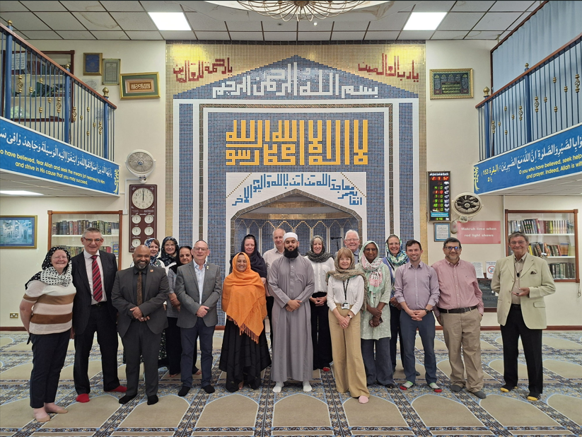

SACRE was delighted to hold its summer meeting in the North Watford Jamia Mosque. Before the meeting, we enjoyed a tour and learned about the Mosque’s history, development, and Islamic beliefs. Visits such as these are invaluable in helping us deepen our understanding of different faiths and denominations, while also recognising the shared values that unite us.
The Mosque welcomes school visits.
01923 682325
info@watfordmosque.org.uk www.watfordmosque.org.uk

Continuing Professional Development Opportunities
Hertfordshire SACRE RE Network Meeting
The last SACRE RE Network Meeting, held on 19 May 2026, focused on assessment.
We were also delighted to have a presentation from the RE Lead at Lea Primary school who shared their school’s RE section of their website and information about the RE curriculum. To access the slides and resources please use this link: RE and SACRE: newsletters and networking - Hertfordshire Grid for Learning
The next dates for the RE Networks will be
- Tuesday 13th October 2026, from 4pm to 4.45pm (Primary)
- Thursday 15th October 2026, from 4pm to 4.45pm (Secondary)
Please email juliet.whitehead@hertfordshire.gov.uk
to book a place. There is no cost.

Thinking about RE: recent reading and resources
From Silence to Voice: Representation and Misrepresentation in RE
RE has an important role in helping pupils understand religious and non-religious worldviews, but it is also important to ask whose voices and experiences are represented in our curriculum. This thought-provoking RE:ONLINE series explores representation and misrepresentation in RE and raises important questions about how we portray diversity and lived experience in the classroom.
Read Part 1: From Silence to Voice
Teaching Judaism and Jewish life
Hertfordshire is home to significant and diverse Jewish communities. Jewish Living Online, together with the Board of Deputies’ teacher Q&A sessions, can help schools move beyond generic descriptions of Judaism and encounter contemporary British Jewish voices, lived experience and diversity within Jewish traditions.
Explore Jewish Living Online

Updated Faith Visits Directory
Hertfordshire SACRE’s updated directory to help schools contact local faith communities and places of worship can be accessed using this link: sacre-directory-2026
Guidance for visits to places of worship
Visits to places of worship remain an important part of high-quality Religious Education. Hertfordshire guidance is available to support schools with preparation, risk considerations and planning meaningful educational visits. Please refer to the guidance for schools in relation to risk and faith visits on the Hertfordshire Grid for Learning. Guidance for schools in relation to risk and faith visits

Here to Help
Whether it’s meeting statutory requirements, boosting engagement, or finding creative solutions to staffing challenges, we are here to support Hertfordshire schools with tailored advice, resources, and networks. Please contact Shammi Rahman Shammi.Rahman@hfleducation.org or Juliet Whitehead regarding SACRE specific questions juliet.whitehead@hertfordshire.gov.uk

