Record of Concern
Information Required | Enter Information Here
Time & date of incident
Child’s full name
Child’s date of birth
Child’s gender
Child’s class/tutor group/form group
Reporter’s name and position in the school
(if visitor also add contact details)
Nature of concern/disclosure
In factual terms include:
- Location when child disclosed

- Who else was present

- What you saw

- The child’s words /actions

- Your response/actions (inc. any open-ended questions to clarify)

- Observations of child’s behaviour

- Signs of injury or pain (if so, illustrate on body map)

- Other children or adults involved?

- Have there been previous similar concerns?

- Any professional views to add
Name and position of the person you are passing this information to
Time and date form completed
Reporter’s (your) Signature
Checklist for DSL (to be printed on back of record of concern form)
- Child clearly identified?
- Name, designation and signature of the person completing the record populated?
- Date, day and time of any incidents or when a concern was observed?
- Date, day and time of written record?
- If a third party has raised concerns, are details of this person included (name, relationship to the child and their contact details if relevant)?
- Distinguish between fact, opinion and hearsay
- Concern described in sufficient detail, i.e. no further clarification necessary?
- Child’s own words used? (Swear words, insults, or intimate vocabulary should be written down verbatim)
- Are the names of all parties who were involved in the incident, including any witnesses to an event included? Is it clear what their relationship is to the child?
- Record free of jargon?
- Written in a professional manner without stereotyping or discrimination?
- What did the member of staff say or do in response to the concern?
- Record of concern completed in a timely manner?
- Record of concern passed to DSL in a timely manner?
- The record includes an attached completed body map (if relevant) to show any visible injuries (body map available at www.thegrid.org.uk/info/welfare/child_protection/proformas/index.shtml )
- Is any additional paperwork, e.g. handwritten notes of conversation with parents attached securely to this record?
- Has DSL completed their sections in full- including action taken and outcome, feedback to staff and information sharing?
- If the concerns have not been referred to Children’s Services/Police, are the reasons clearly recorded by the DSL?

Audit date: |  | Audited completed by:
Overall RAG rating (see key below)
Action needed | Timescale |  | Name and position of person responsible | Date action completed

RED | Indicates that information from the checklist is lacking and deficiencies need to be addressed as a matter of urgency
AMBER | Indicates that key information is included but recording could be further improved
GREEN | Indicates that the recording meets the above required standards

If you intend to give a copy of the above action plan to the member of staff, please ensure they are not given page 1, i.e. the actual record of concern form which contains confidential details.
Body map
page 1 of 2
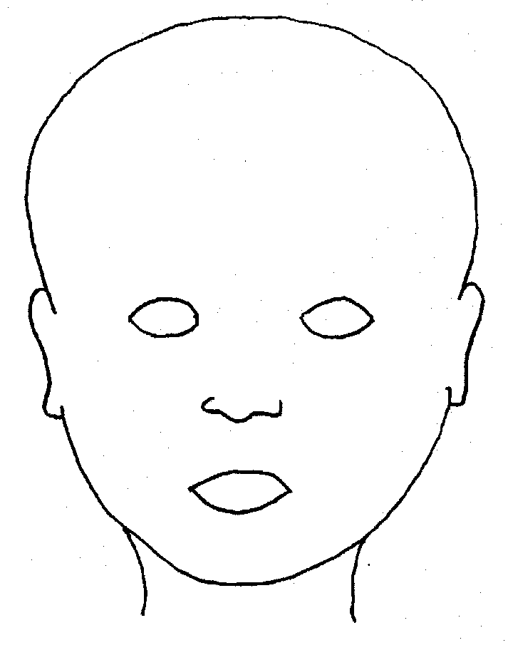

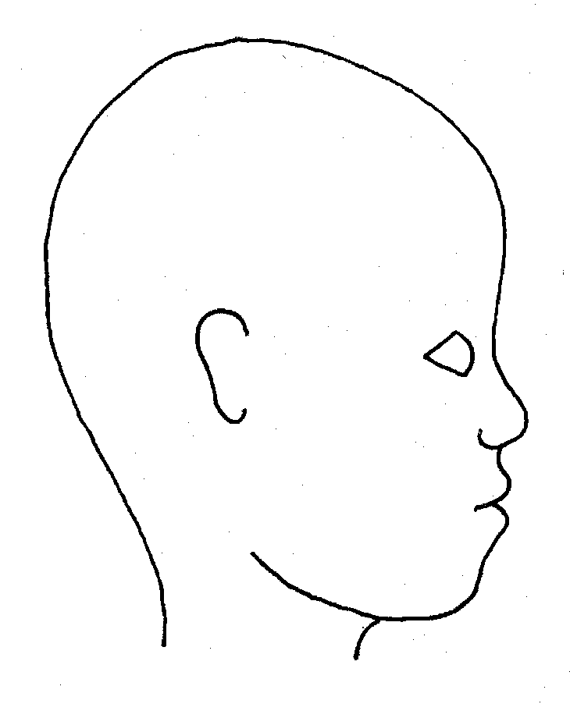
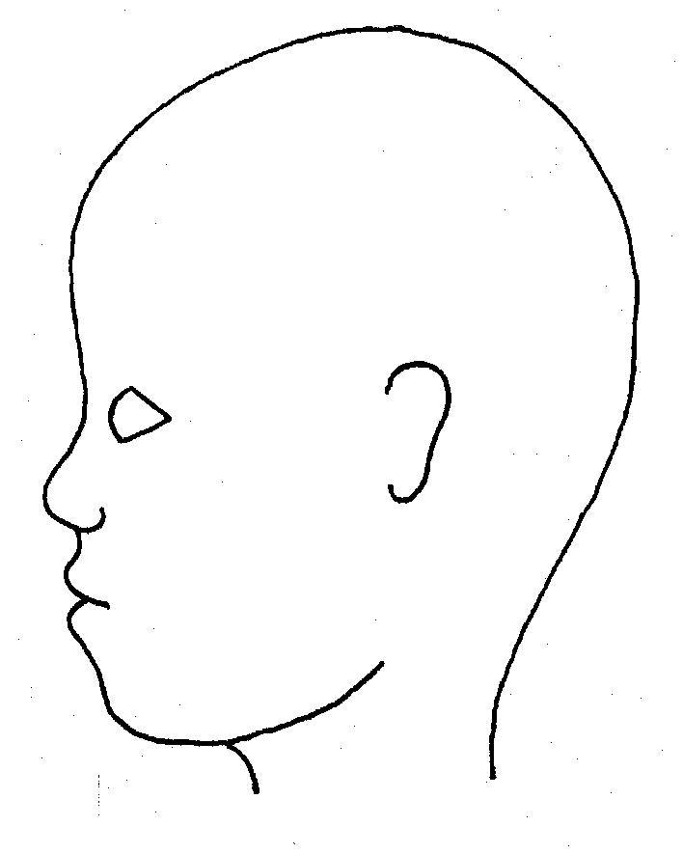


Description/notes:
Front
Back
Right
Left
Front
Back
Body map
page 2 of 2
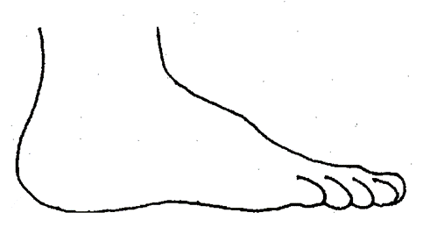
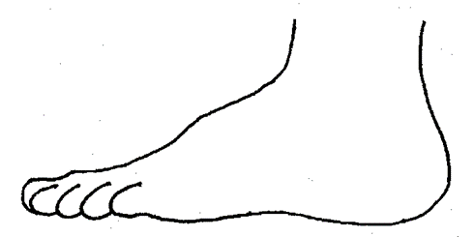
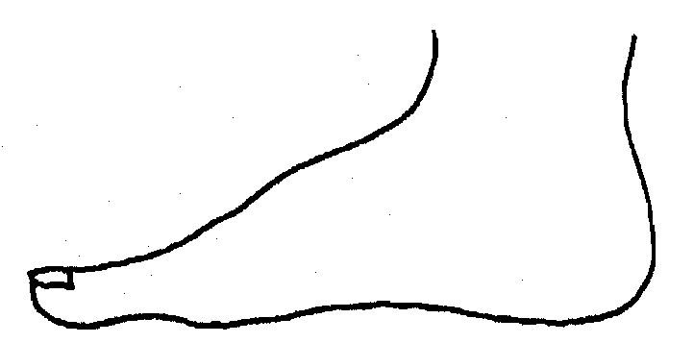
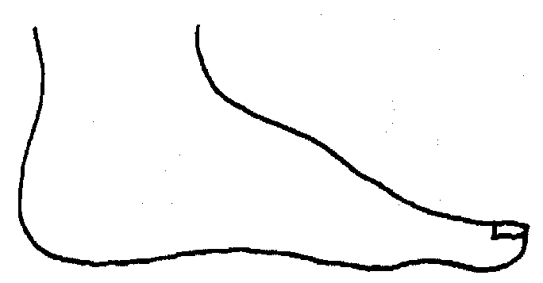
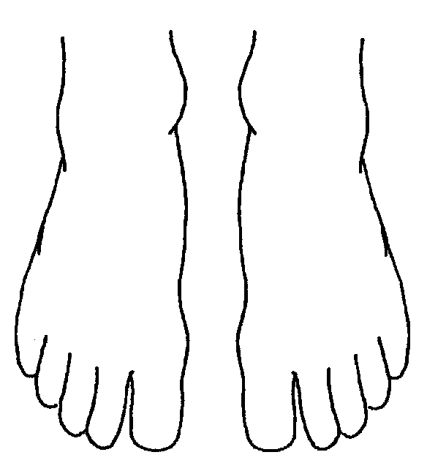
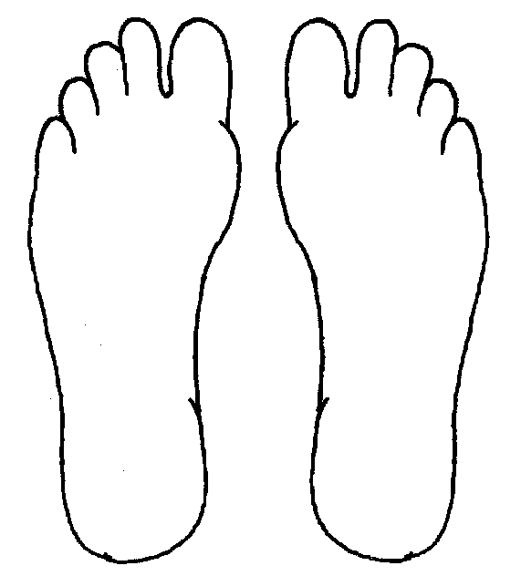
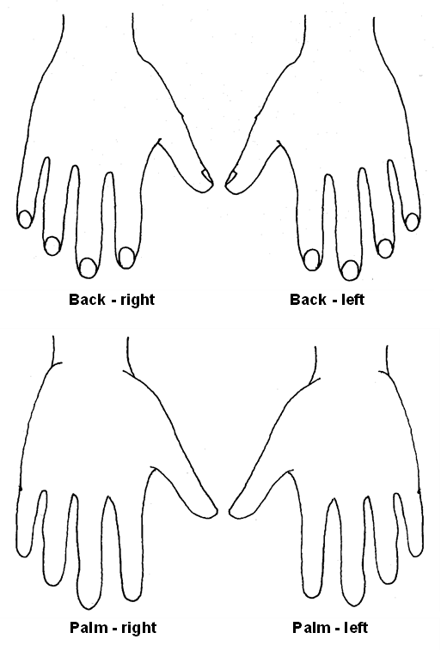
Right OUTER Left
Right INNER Left
Right TOP Left
Description/notes:
Right BOTTOM Left

Record of Concern Action form
Actions / Request for Support and rationale
For completion by DSL / DDSL |  |  | Page 1 of 2
(D)DSL’s immediate response and actions taken

Include:
- Any further information gathering

- Speaking to the named CYP or others

- Has any immediate risk assessment been carried out, and if so, what?
Information shared with Parents / carers?  - Date/time  - Are they aware of school’s concerns / actions carried out to support / safeguard CYP?  - Parent/carer’s response  - Do you have consent for this? If not, rationale for not sharing information? | The only reasons not to share information with parents are:  - Doing so would place the child at increased risk of significant harm through this action  - There would be an impact on a criminal investigation  - The delay in being able to get in touch with parents before making the Request for Support would impact on the immediate safety of the child
Feedback given to child
[yes/no (why), date and time]
Record of Concern Action form
Actions / Request for Support and rationale
For completion by DSL / DDSL |  | Page 2 of 2
Request for Support made to Children’s Services?

- ☐ Yes, Which agency/service:
☐ No

- Rationale for actions and above decision:

If referring:

- Parental consent gained?
☐ Yes
☐ No (pick one from below and attach supporting evidence)

The only reasons not to gain parental consent are when:
☐ The child would be placed at increased risk of significant harm through the action of gaining this consent
☐ There would be an impact on a criminal investigation
☐ A delay in making the Request for Support would impact on the immediate safety of the child
Feedback given to reporting staff member

[yes/no and date and time]

Feedback given to other staff members?

[who, rationale for doing so, date and time]

Further Action Agreed
Full Name of DSL
Time and date form completed
Signature of DSL

