# Schools HR and Payroll Service Desk Portal – User Guidance

Contents

Logging into the Portal via 2 Factor Authenticator 2

Raising a Query 9

Adding an attachment 11

Adding a note to an existing query 14

Viewing a response to a query 166

Viewing a query that has been closed. 177

Logging Out of the Portal……………………………………………………………………….19

## Logging into the Portal using Two Factor Authentication (2FA)

When logging in for the first time please follow instructions 1-4 below.

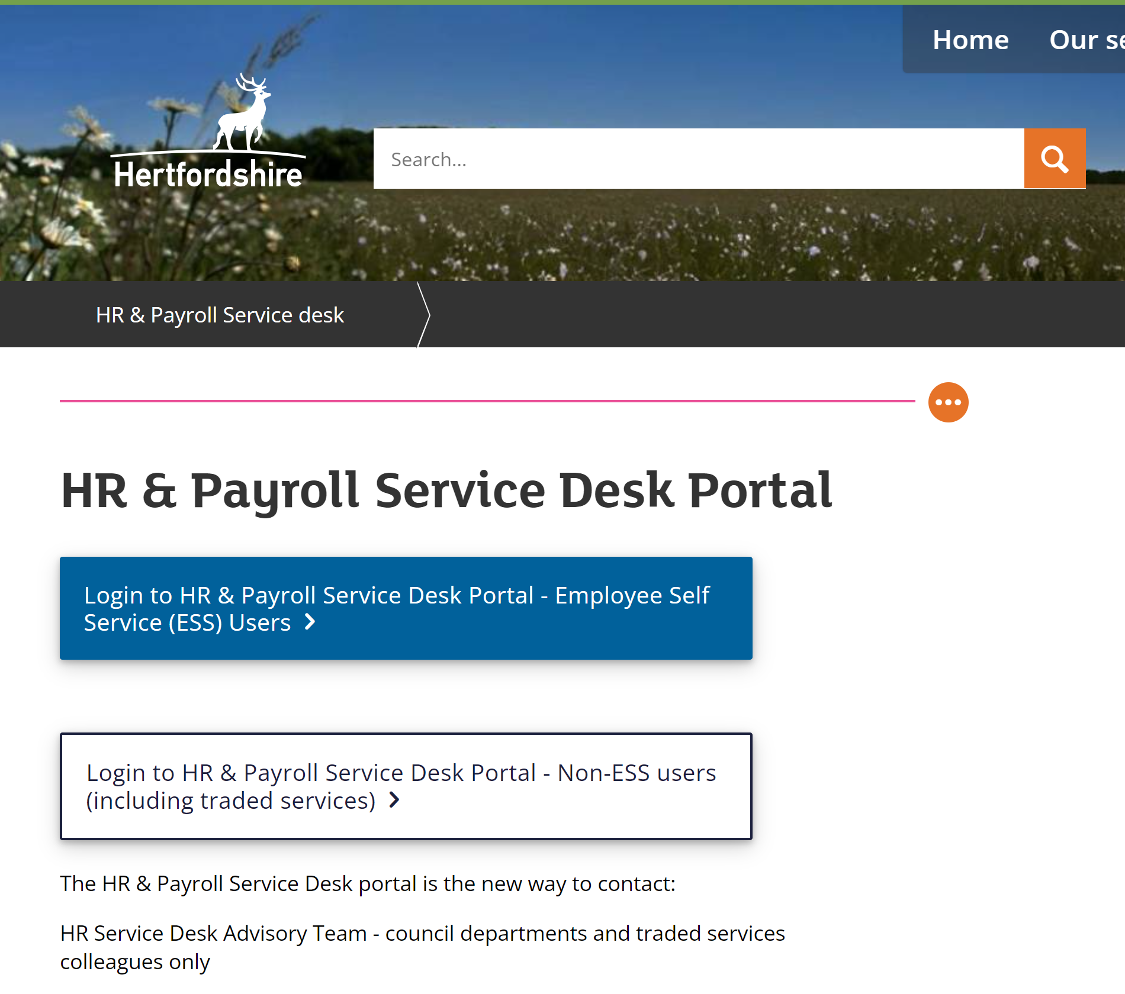

1. From the HR & Payroll Service Desk Portal Page (above) – you will need to select the second (white) button Login to HR & Payroll Desk Portal – Non-ESS users.
2. This will take you to the Login screen below, you will need to use your personnel/payroll number in the username field. Please select ‘Forgotten your

login details?’ to create a password via email link. 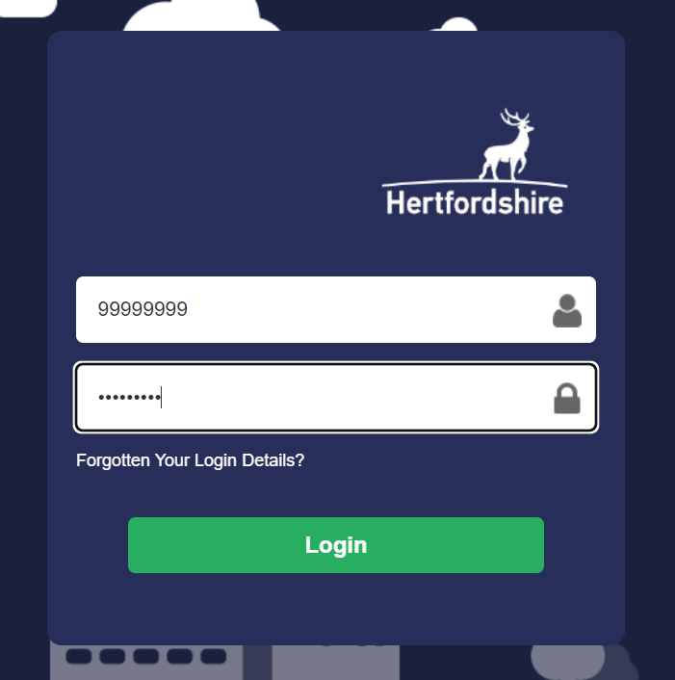

1. You will receive an email with a link to create your password, follow the steps to login.
2. When you have created a password, it can be used with your login (personnel/payroll number) each time you log in. The second stage of the log in process is to authorise which is described below.

Authorisation stage of logging in

There are 2 options you can use to authorise (the second stage of logging in). Both

are described below. 2 Factor Authentication (2FA) consists of the above stage of

entering your username and password, followed by authenticating (instructions

below).

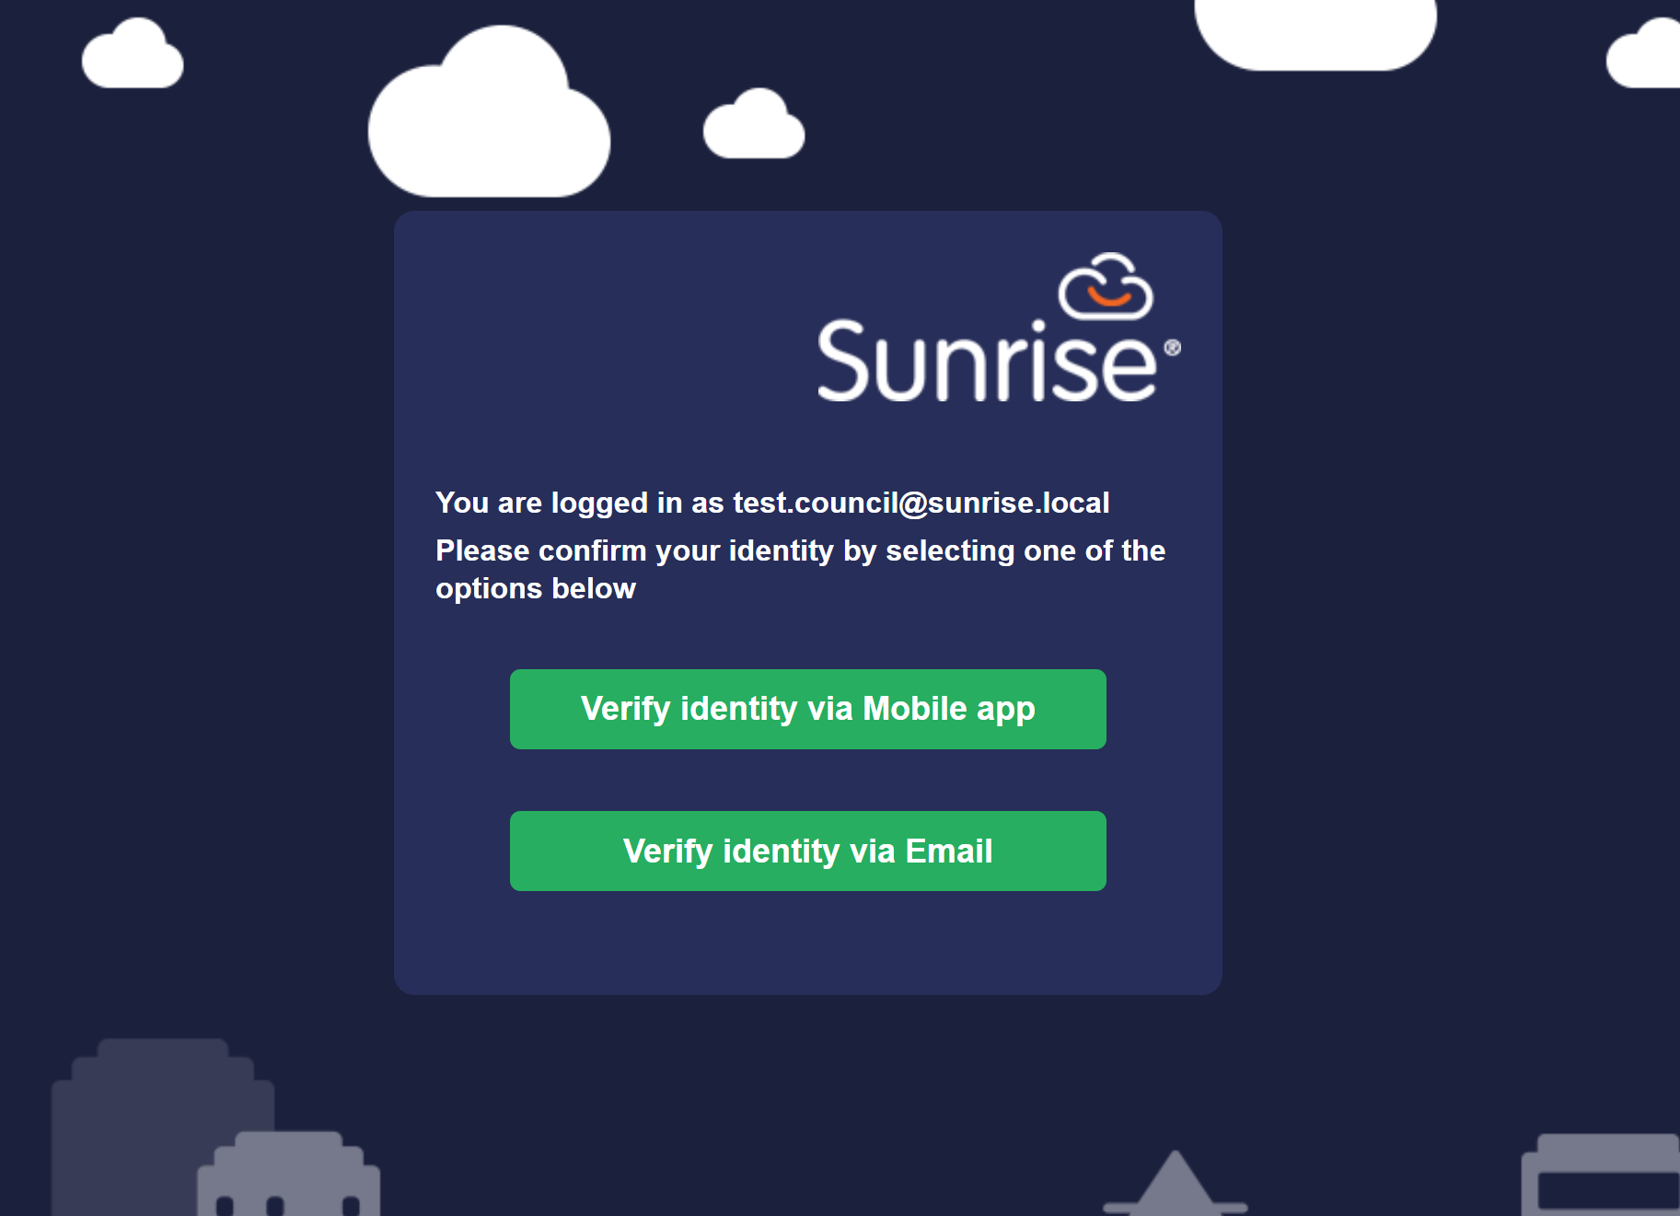

### **Option 1 – Verify via Mobile app (Microsoft Authenticator App)**

1. This option is best if you are using a mobile device or tablet.
2. To download the app, you will need to go to your app store on an apple device:

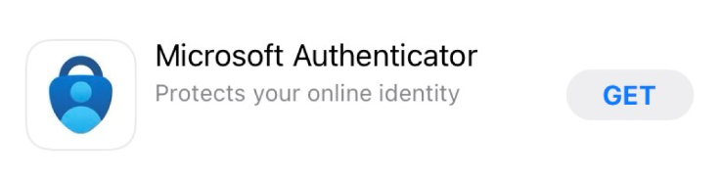

or google play store on android

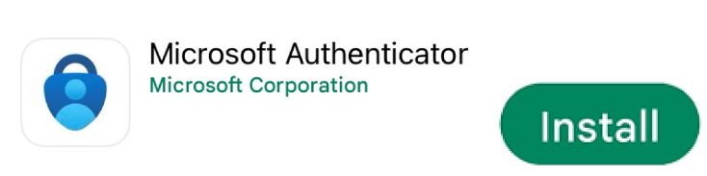

1. Once you have downloaded the app you will need to select the + sign to add an account

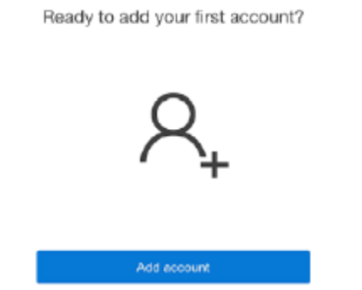

1. Then select Other, the app will ask for access to the device Camera to scan the QR code

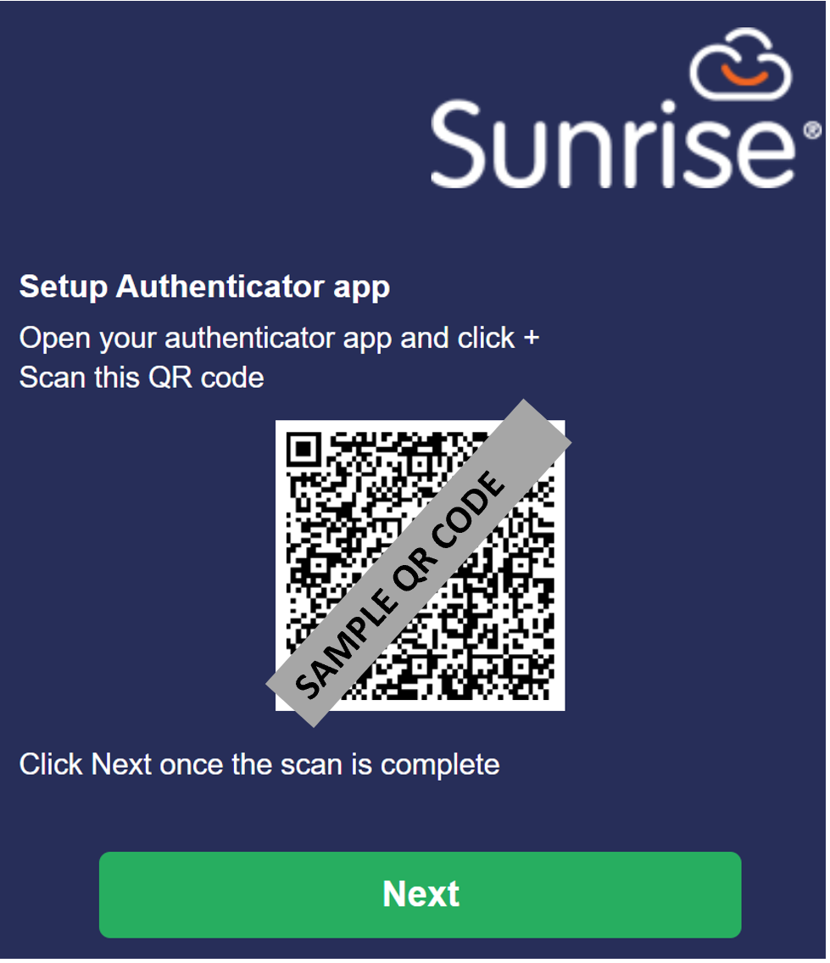

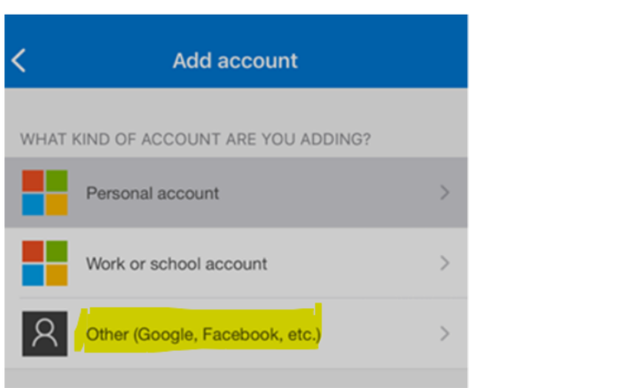

1. Once the QR code has been scanned into the authenticator app it will display as below – the code will expire after 60 seconds
2. Highlighted in yellow is where the 6-digit code will display

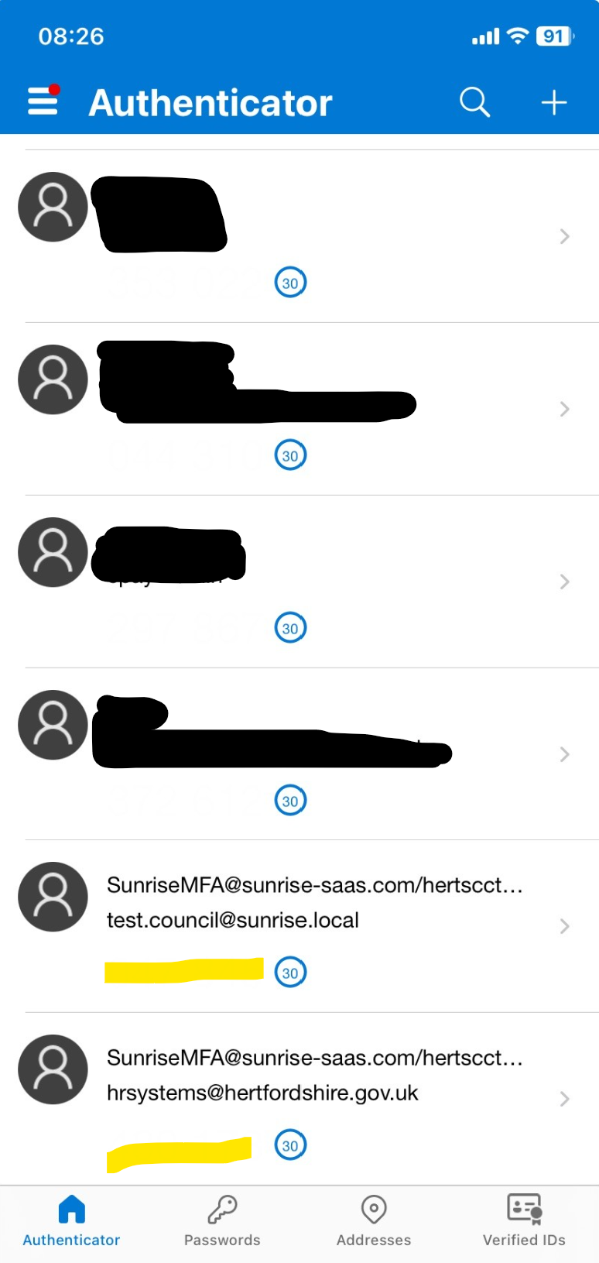

1. The code then needs to be entered into this field and the verify button needs to be selected.

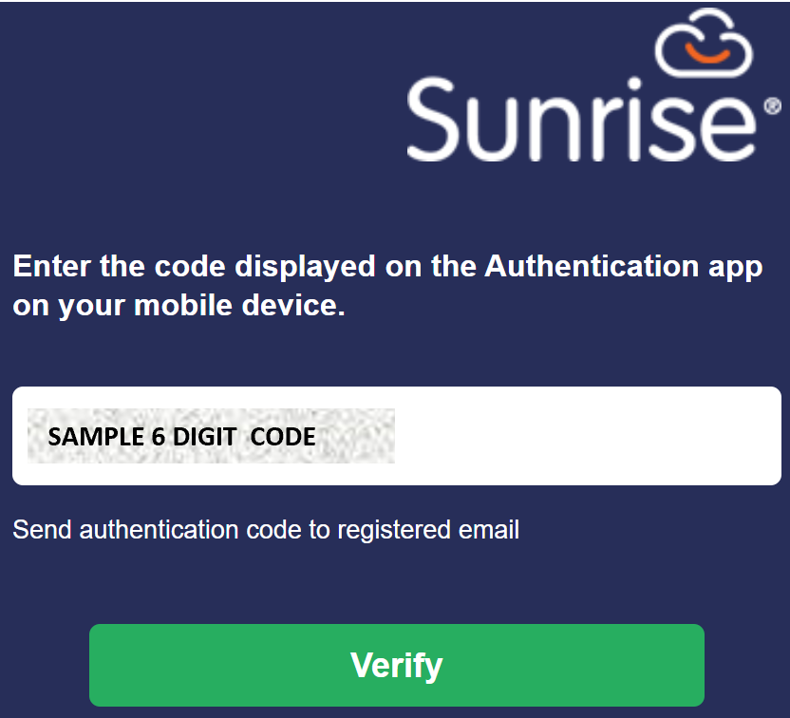

1. Once Verify has been selected you will then be taken through to the Schools HR & Payroll Service Desk Portal homepage. You will only have to verify once a day, you can then log in and out as many times as required on that day without having to go through the 2FA process again.

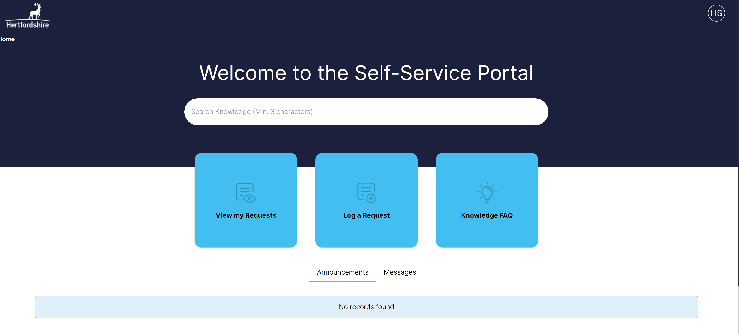

### **Option 2 – Verify identity via email**



1. Selecting Verify identity via email will generate an email from [support@sunrisesoftware.com](mailto:support@sunrisesoftware.com) to the email address registered on the Schools HR & Payroll Service Desk Portal. This is either your normal work email or (if you do not have a work email) a personal email you have supplied and has been uploaded to SAP. This will be an email address you shared for Epay access. The email will be titled Account Identity Security code and will include a 6-digit authentication code.

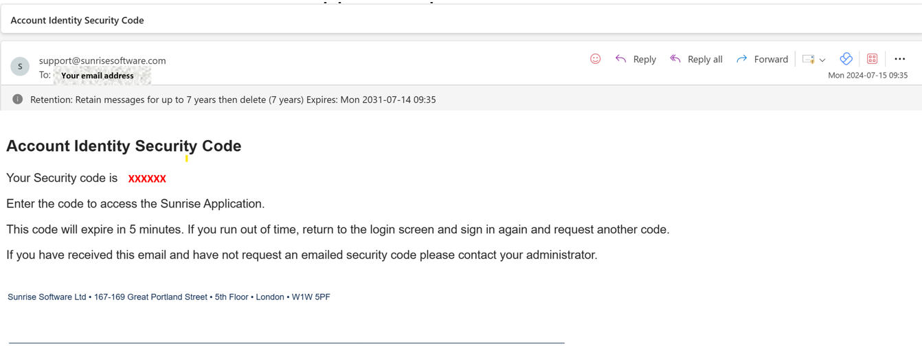

1. Enter the 6-digit code from the email into the field shown below and then select Verify. You will only have to verify once a day, you can then log in and out as many times as required on that day without having to go through the 2FA process again.

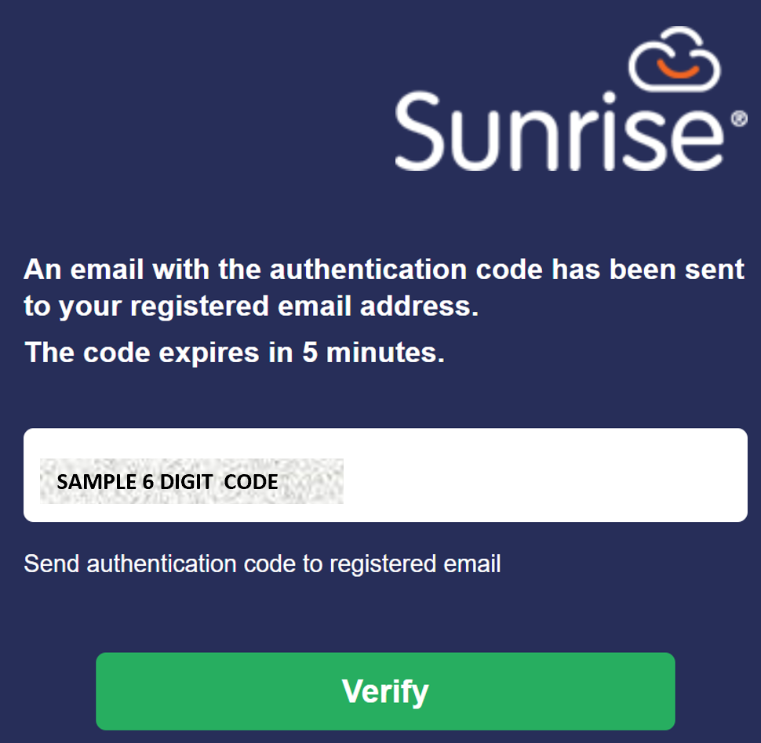

1. You will then be taken through to the Schools HR & Payroll Service Desk Portal homepage.



1. For guidance on how to use the Portal please see below.

## Raising a Query

1. From your **Home screen,** click on **Log a Request:**

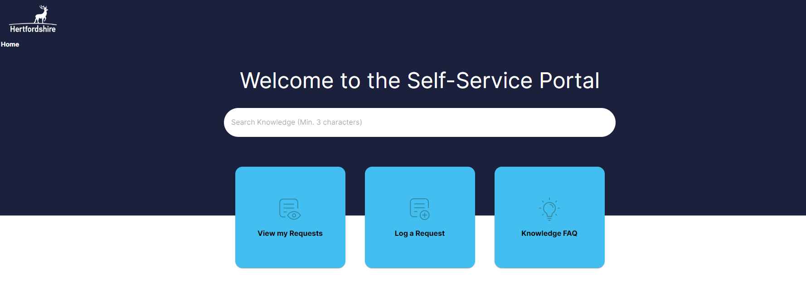

1. Click on the button most relevant to your query, this will bring up a short form to complete.

**Payroll buttons:**

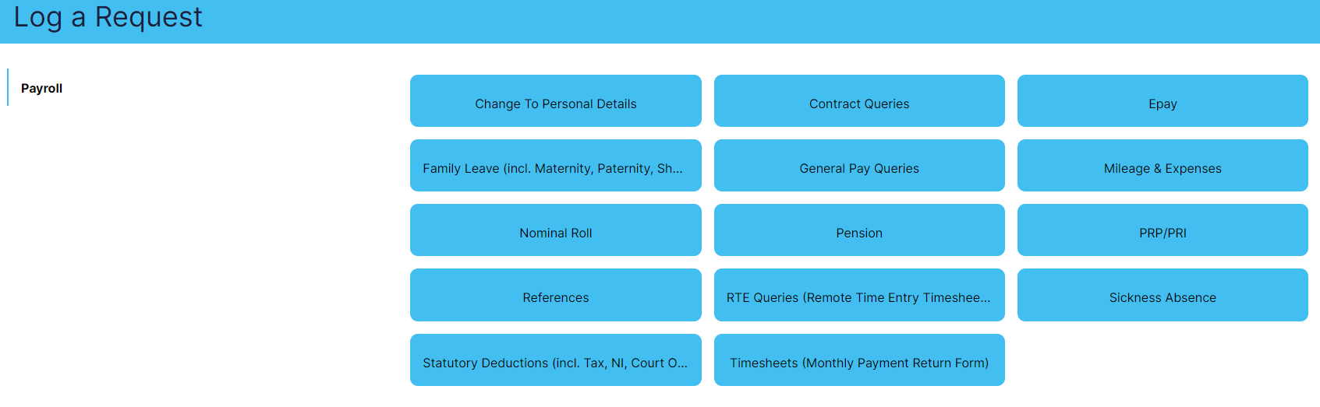

1. Go through the form and complete all of the information requested:

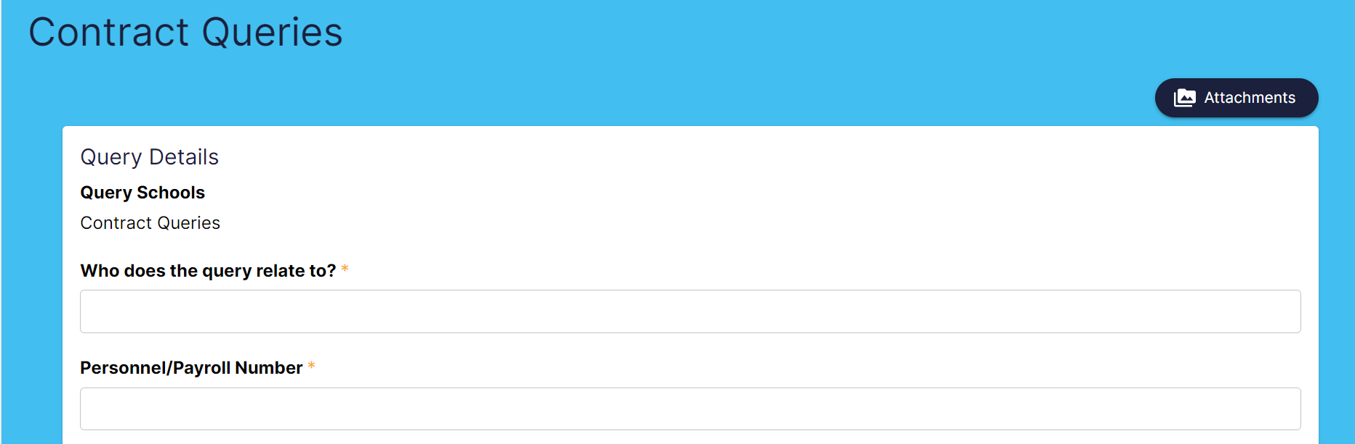

* 1. If you are contacting us about an employee, please ensure that you provide details of the employee you are raising the query about.
  2. Please ensure that you answer any relevant questions within the **Query Details** box. This will help us to respond fully to your query

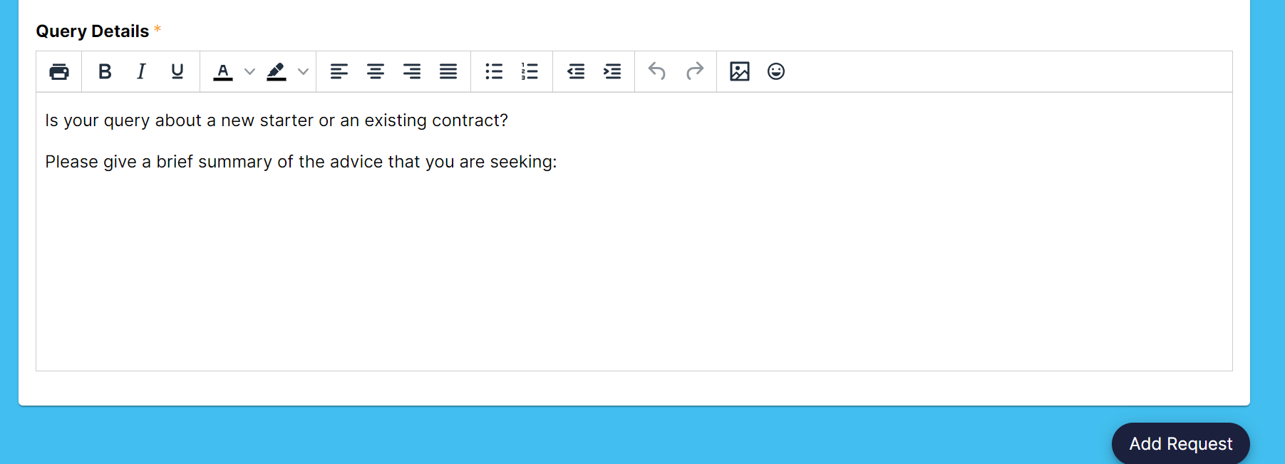

1. If you need to add an attachment to your query, click on the **Attachments** button and follow the guidance below.

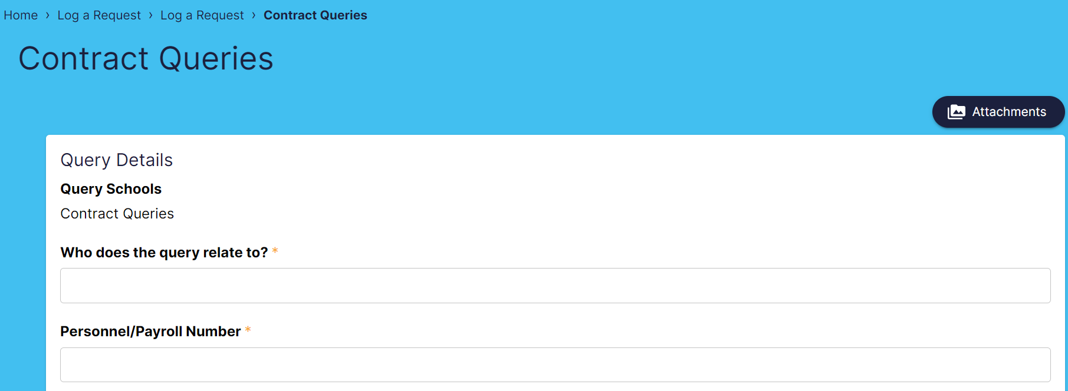

1. If you are not attaching any further documentation, then once you have completed all information requested, click on **Add Request**.

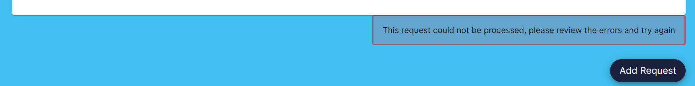

## Adding an attachment

1. Click on the **Attachments** button:



1. The following panel will appear

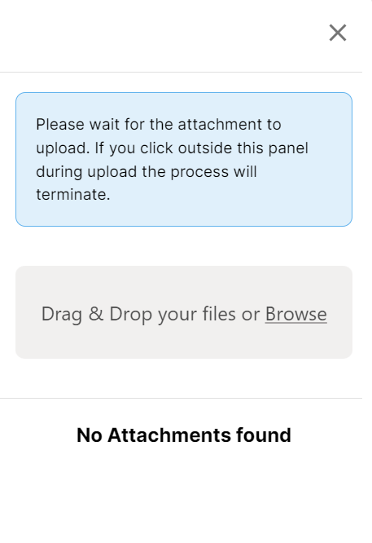

To attach a document by browsing your File Explorer:

* 1. Click on **Browse,** see above.
  2. Select the attachment you want to attach to the query from your personal files. Please take care to attach the correct document as it is not possible for you to delete a document attached in error.
  3. Then click ‘Open’

To attach a document by using Drag & Drop:

1. Open your **File Explorer** and find the document you wish to attach.
2. Click on the file and drag the file from the File Explorer into the **Attachments** panel, ensure it is dropped into the grey box:

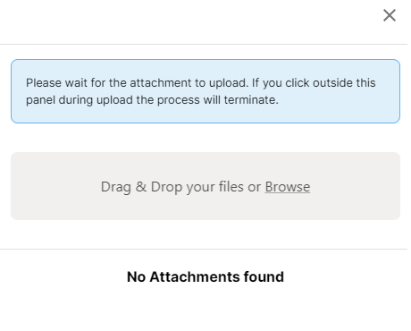

1. You will then see the document in the panel – as below, click on the x to close the panel, the attachment will still be attached to the query, and you can check if required by clicking on the **Attachments** button again.

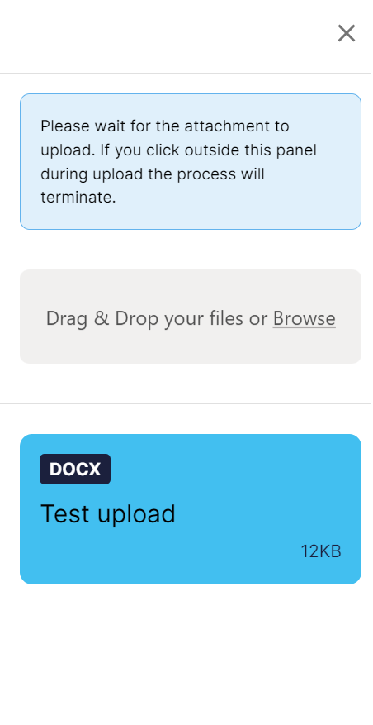

Then click on **Add Request.** If any of the required fields are not completed, you will see the error message below, please go back and add any missing details before clicking on **Add Request** again.

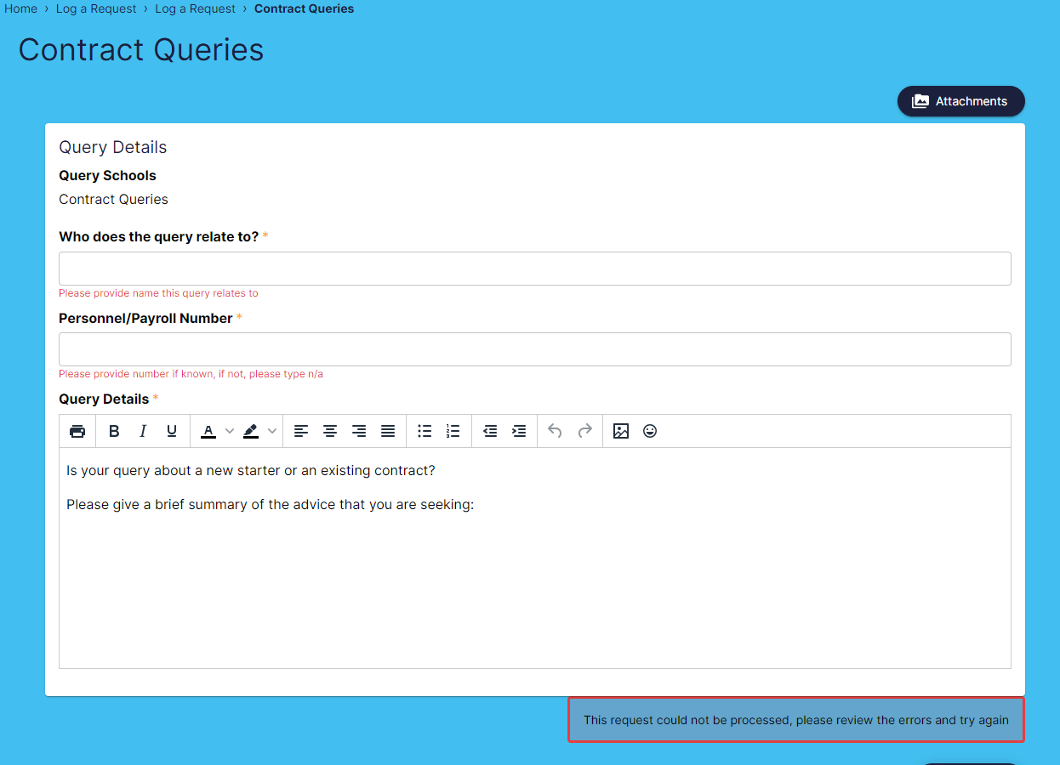



1. Your query will now be available in **View my Requests** from your **Home screen,** and you will receive an email to confirm that it has been received. The email will provide a link to view your query in the portal.



## Adding a note to an existing query

1. Click on **View my Requests** and select the query that you would like to add more information to:



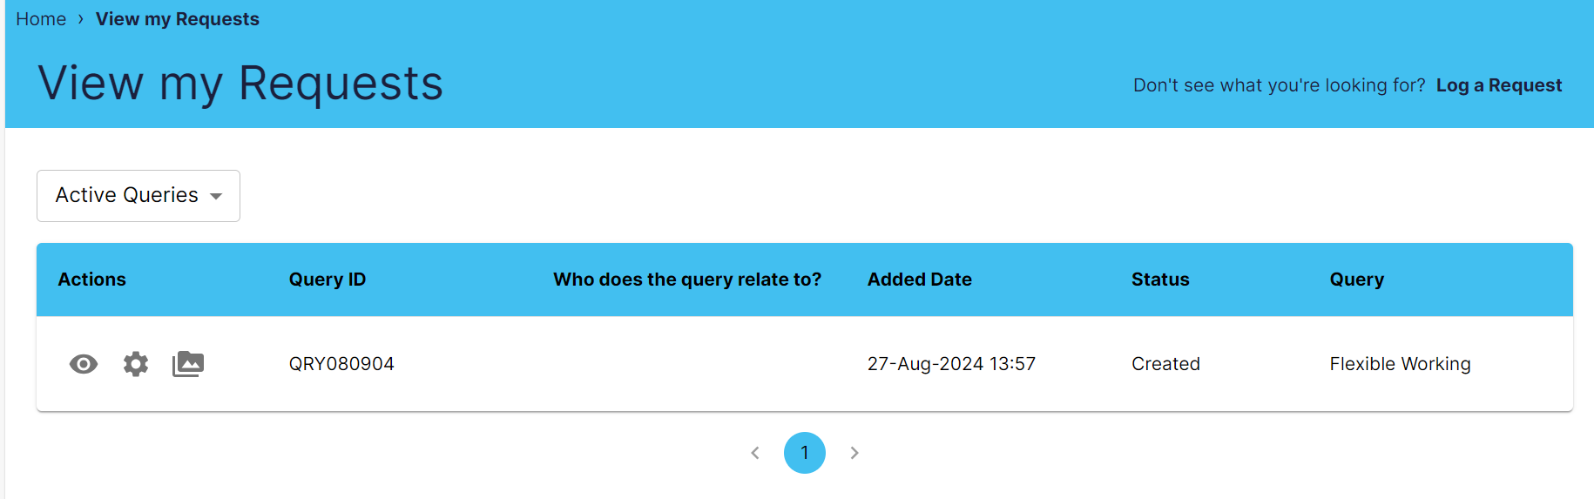

1. Here you can **View Record** by clicking on the eye icon under **Actions** and you can **View Attachments** by clicking on the folder icon.
2. Click on the cogicon to **Perform Action** then click on **Add Note.**

Image of the Actions menu highlighting the folder button required to Add a note to an existing query.


1. Please add any further information to the existing query then click on **Submit.**

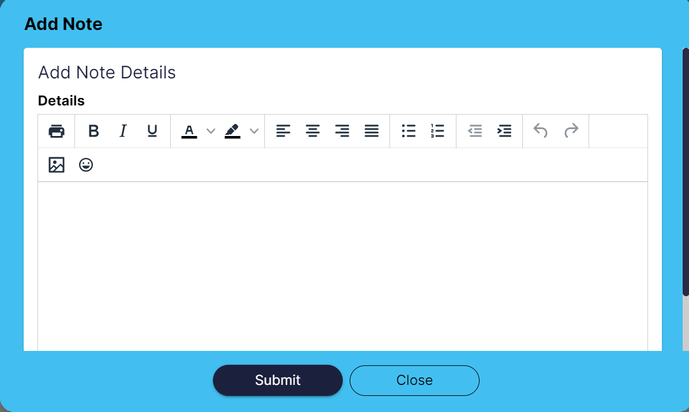

1. Click on the eye icon under **Actions** on the relevant query to see the updated information within the query.



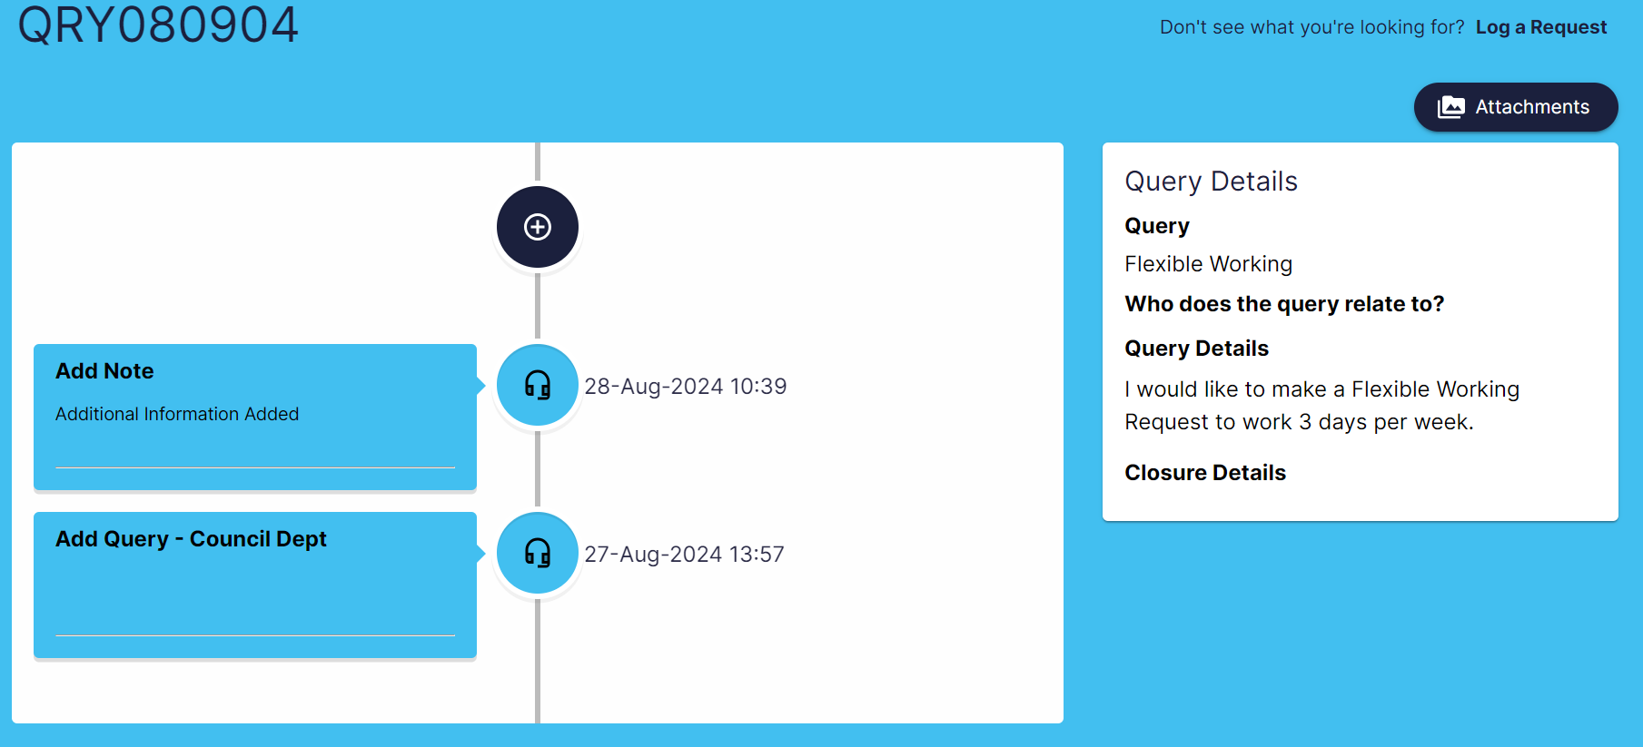

## Viewing a response to a query

1. Once the Schools HR Payroll team has responded to your query, you will receive an email to confirm that you have a response waiting and provide a link to take you straight into your home screen. Click on the link and you will be asked to log into the system where you can view the response.
2. Select the relevant query and you will be able to see the query response in the details history:

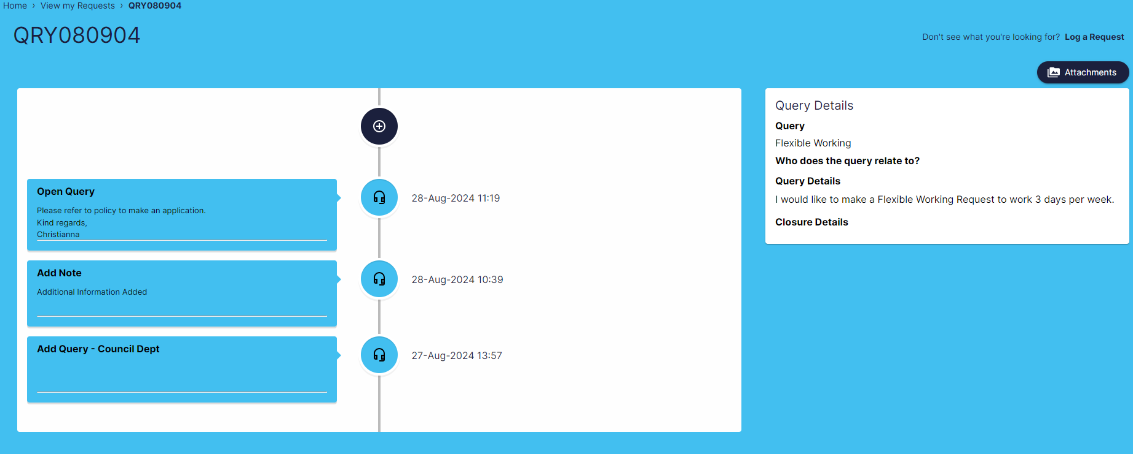

1. If the Schools HR Payroll team require further information from you, then you can respond by using the **Add Note** function.  
   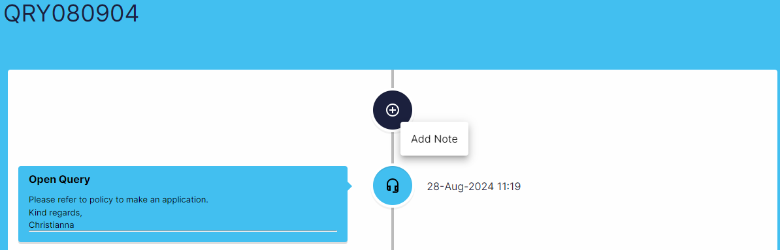
2. If you need to add an attachment, then you can do so while in the relevant query by clicking on the **Attachments** button (please see guidance above).

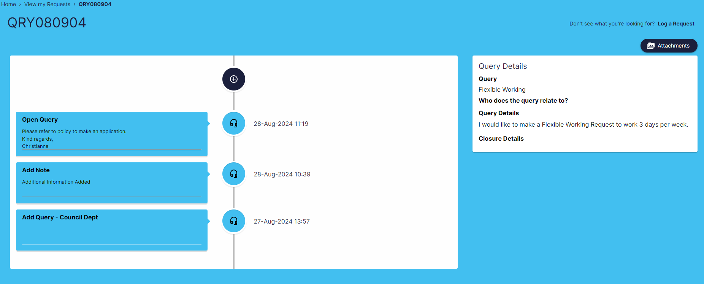

### **Viewing a query that has been closed.**

1. If the Schools HR Payroll Team has provided an answer to your query and no further information is required, then the query will be closed. You will receive an email to confirm the query has been closed. The email will also provide the link to log in and view the query response. It will now show in the **Recently Closed Queries** dropdown list within **View my Requests**



1. You will be able to see that the query has been closed in the query details history with any additional comments from the Schools HR Payroll team:

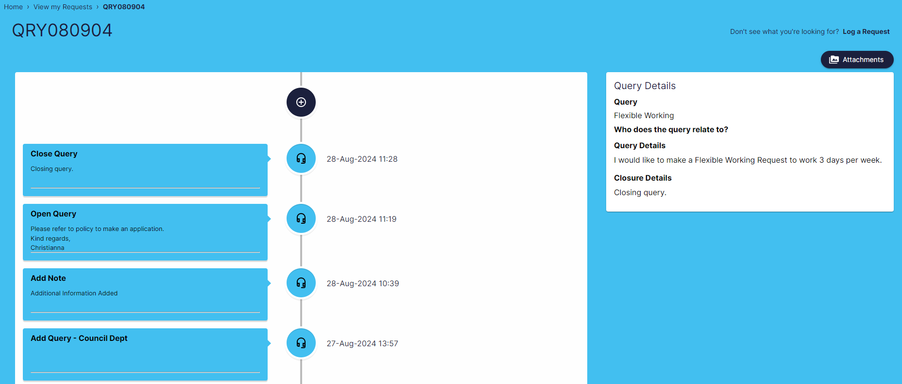

1. If the query has been closed but needs to be re-opened due to there being further information or advice required, you can contact the Schools HR Payroll team by calling the Ask Us telephone line 01992 556500, Option 5.
2. The Schools HR Payroll team will be able to reopen the query so that you can review and add further information/ask further questions as required. You will receive an email when the query has been reopened to confirm and provide a link for you to re-access the query details.

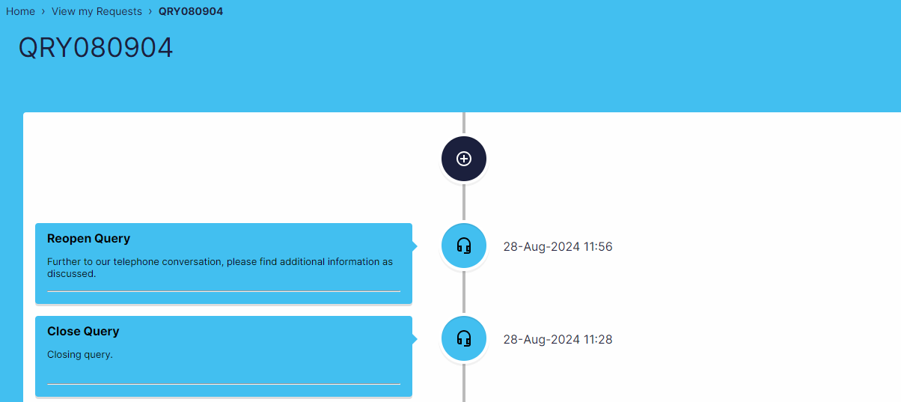

1. The query will show as reopened in the query details history and will reappear in your **Active Queries** list within the **View my Requests** screen**.**

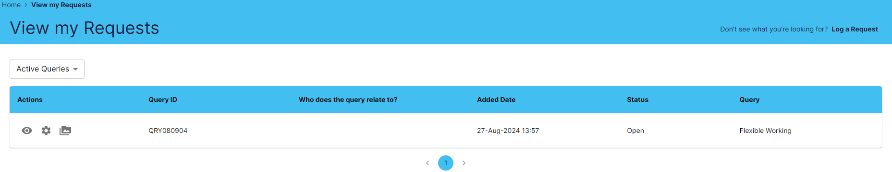

1. From here you can use the **Actions** icons toview the query and add attachments and any notes as required.

**Logging Out of the Portal**

Please ensure that when you have finished using the portal you log out fully. This will ensure you can successfully log back into the system when you next need to use it.

1. Click on your initials in the top right-hand corner of the home page.
2. Select Logout
3. Close the tab within your browser.

